The articles provided:

[Observation of a Many-Body Dynamical Phase Transition with a 53-qubit Quantum Simulator](https://www.nature.com/articles/nature24654). *Nature*, volume 551, pages 601–604 (30 November 2017) [[PDF download]](https://arxiv.org/abs/1708.01044)

[Scalable Quantum Simulation of Molecular Energies](https://ai.google/research/pubs/pub44815). *Physical Review X*, vol. 6 (2016), pp. 031007 [[PDF download]](https://arxiv.org/abs/1512.06860)

[Hardware-efficient Variational Quantum Eigensolver for Small Molecules and Quantum Magnets](https://www.nature.com/articles/nature23879). *Nature*, volume 549, pages 242–246 (14 September 2017) [[PDF download]](https://arxiv.org/abs/1704.05018)  
  
Done by Satenik

1. These are three experimental demonstrations of quantum simulations. Noting its relative date of publication, describe your chosen paper's impact in the business trade press. Do you feel it had the largest influence of the three? Why or why not?

Firstly, in the first page of the second article (“Scalable Quantum Simulation of Molecular Energies”. Physical Review X, vol. 6 (2016), pp. 031007) we see familiar institutions and companies such as Google, Harvard University, University of California, Santa Barbara, Lawrence Berkeley National Laboratory, University College London and Tufts University. It’s not a secret that big institutions such as these have privileges in the sphere of media coverage. Moreover, out of the three given articles, “Scalable Quantum Simulation of Molecular Energies” got the most reviews and here are some of them.  
  
“First completely scalable quantum simulation of a molecule” by Bob Yirka, Phys.org  
<https://phys.org/news/2016-07-scalable-quantum-simulation-molecule.html>

“Google’s Quantum Computer Just Accurately Simulated a Molecule For The First Time”

By David Nield   
<https://www.sciencealert.com/google-s-quantum-computer-is-helping-us-understand-quantum-physics>

“Quantum computer simulates hydrogen molecule” by Philip Ball

<https://www.chemistryworld.com/news/quantum-computer-simulates-hydrogen-molecule-/1010041.article>

“Google boasts quantum computing breakthrough with first display of real-world use” By Mary-Ann Russon  
<https://www.ibtimes.co.uk/google-boasts-quantum-computing-breakthrough-first-display-real-world-use-1571823>

The experiment was done with the usage of phase estimation algorithm (PSA) and variational quantum eigensolver (VQE). Whereas, PSA is for computing the energy of the molecule and VQE was for accuracy.

Particularly in the article by Bob Yirka “First completely scalable quantum simulation of a molecule”, it is very well presented by the author, the importance of the experiment. As explained, previously the energy of the molecules were calculated with the help of classical computers. Some experiments, such as the calculation of propane, could take days to be computed. While with the help of quantum computers the same experiment can be done in a shorter time. Also, as shown in the “Scalable Quantum Simulation of Molecular Energies”, the results of two experiments, the one done with a classical computer and the other - with a quantum computer, are nearly the same.

Done by Satenik

2. Two of the papers employ superconducting qubits, and were from research at large corporations, while one paper describes research using atomic qubits, performed at a research university. Based on how these results were received in the news press, can you see how the technology, and the research institution, made a difference in expectations for future developments?

It is meaningless to discuss how huge differences can have a functional quantum computer make for corporations, countries, organizations etc. There is an enormous demand for having a working quantum computer that will solve problems that are not applicable to classical computers or that will take a huge amount of time to be computed, that is why there is an enormous competition in trying to make one.

Furthermore, it is quite notable that the Google Research Team’s project was released sooner than the other projects, which are “Observation of a Many-Body Dynamical Phase Transition with a 53-qubit Quantum Simulator” and “Hardware-efficient Variational Quantum Eigensolver for Small Molecules and Quantum”. The latter ones were published in 2017, whereas the “Scalable Quantum Simulation of Molecular Energies” by Google Research Team was published in 2016, a year before. We believe that being a “pioneer” in this field rewards with much more media coverage in the press. Moreover, the variational quantum eigensolver algorithm that was implemented in Google's experiment, was enhanced by them, so after when the two other teams did their projects they already used the improved algorithm.

Additionally, no matter in which sphere of studies or branch of industry we are speaking about, big names, in this context - Google, receives much more attention from the general public as well as from industry specialists. This can also be one of the reasons why the project by them was more acclaimed and covered in the press, rather than the other two.

And last but not least, large corporations have the vision that development of quantum computers is going to drastically change the world, and every research paper and project is another step to the future that they envision. They understand that this type of quantum revolution will kick off a lot of new business opportunities.

Done by Marianna

3. Imagine that you are responsible for investing the money of a company or a funding agency interested in the further development of quantum computation. Would you invest your money in your chosen paper's project? Why or why not?

We would definitely choose to fund in our chosen paper and there are several reasons why.

Firstly, nowadays, solving the molecular electronic structure problem is quite difficult, because it is needed to find the lowest energy configuration of electrons for a given nuclear configuration. Our experiment was implemented for hydrogen atoms. Even though it is one of the simplest atoms in nature this investigation can lead into solving molecular electronic structure problems for propane (C3H8) much faster (for a classical computer this can take up to 10 days).

Additionally, A single atom can be in various states at the same time. Bits in classical computers can be either 1 or 0, on the other hand, in quantum computing the value of the qubit can be both 0 and 1. The latter one is called “superposition” in quantum theory. It is not a secret that chemical reactions happening in nature are quantum as those reactions form entangled superposition states. That is the reason why modern classical computers are having issues with computing such reactions. In today’s computers particle’s state cannot be described independently of the others because binary values are not enough.

And finally the last reason I think this paper is worth making investment in is that when we compare the results of the VQE and the actual released energy of the hydrogen molecule, we can barely see any difference between those curves. Below you can find the graphical representation of that difference.

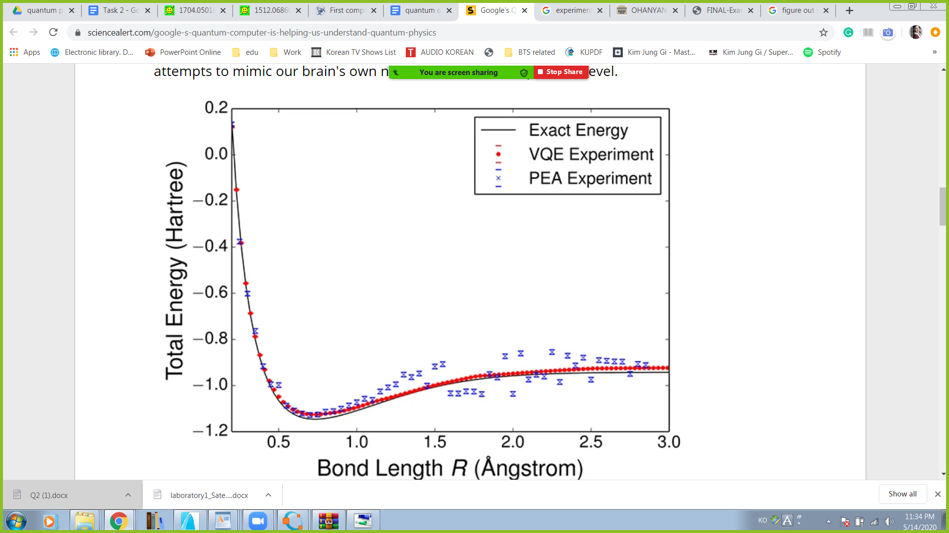

These are the beginning and the first steps of modeling reality, and many believe that soon we will be able to see various applications of quantum technologies in all kinds of fields in the industry. These include the development of improved batteries, new types of materials, flexible electronics, creation of solar cells and even for medical purposes.